“Homeward - The Jolie Brise”
by Martyn Mackrill Signed Print
ORDER FORM
Name:
Delivery Address:
Telephone Number:

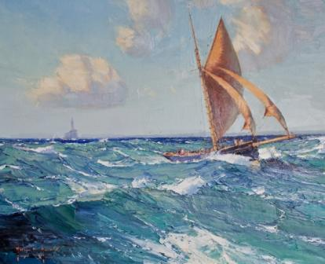
14” x 18” (36cm x 46cm)
£100 per signed print.
Number of Prints:
Postage and packaging £4.95
Total Cost: £

Payment
Please find enclosed a cheque made payable to the Andrew Simpson Sailing Foundation.
Please charge the following Credit/Debit Card Details
Card Number:
Expiry Date: /

Proceeds will go to Andrew Simpson Sailing Foundation.

